

[See foto](https://technofaq.org/posts/2019/07/5-secrets-to-building-an-amazing-mobile-app/), autor: Tundmatu autor, litsents: [CC BY-SA-NC](https://creativecommons.org/licenses/by-nc-sa/3.0/)

FINAL PROJECT

TALLINK SILJA MOBILE APPLICATION

Software Development Academy

Julia Müürsepp

TesterRemoteEE11

Tartu 2023

# Contents

Contents 2

Document Purpose 3

Testing 4

Testing section 4

Testing checklist 5

Detailed test cases 5

Funded issues/bugs 25

Improvements 27

Test Design techniques 28

Reflection 29

# Document Purpose

I am finishing my testing course in Software Development Academy, and this is my final project.

This project shows some Tallink Silja mobile application functionality, what issues could end-users see and what I, as a tester, have learned and how I am able to document it.

# Testing

## Testing section

I tested the Tallink Silja mobile application on IO system, iPhone 12 pro max.  Here is a diagram about mobile application structure.

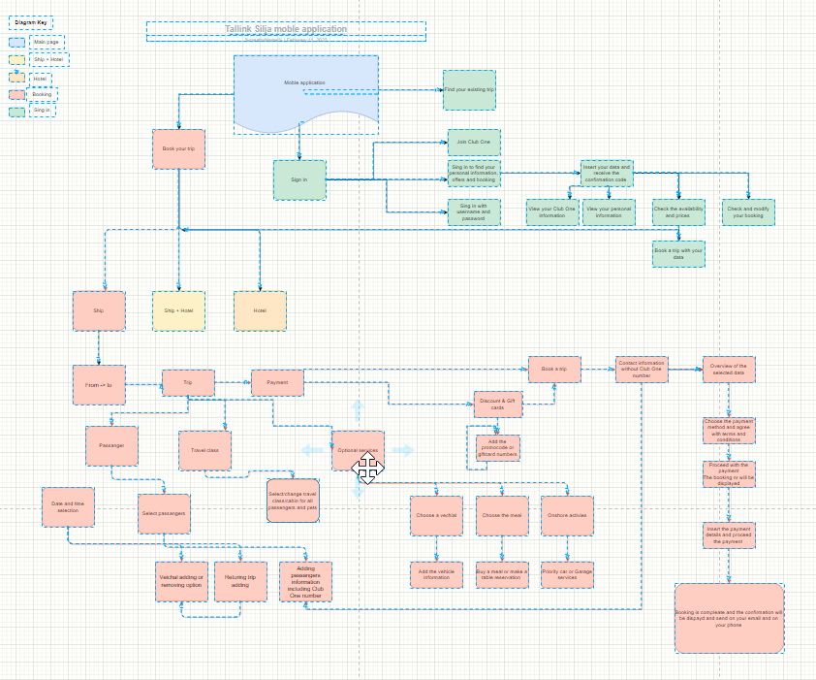

# Testing checklist

|  |  |
| --- | --- |
| Test type | Test scenario |
| Function | Is it possible to select different destination for the trip |
| Function | Is it possible to select different dates for the trip |
| Function | Is it possible to select different departures time |
| Function | Is it possible to add and remove the passengers |
| Function | is it possible to select different travel classes |
| Function | Is it possible to select different optional services |
| Function | Is it possible to add different return dates |
| Function | Is it possible to add different return times |
| Function | Is it possible to change the departure dates |
| Function | Is it possible to change the departures times |
| Function | Is it possible to add the passengers |
| Function | Is it possible to change the optional services |
| Function | Is it possible to add the optional services on the departure |
| Function | Is it possible to add the optional services on the return |
| Function | Is it possible to add passengers on the return |
| Function | Is it possible to add the optional services on return |
| Function | Is it possible to select the vehicle |
| Function | Is it possible to change the vehicle category |
| Function | Is it possible to add another optional service on the return trip |
| Function | Is it possible to change the passenger age |
| Function | Is it possible to change the optional service another time |
| Function | Is it possible to change the optional services |
| Function | Is it possible to make a booking without valid account |
| Security | Is it possible to proceed with payment |
| Security | Is it possible to proceed with invalid payment information |
| Security | Check if it is possible to log in with phone number |
| Security | Check if it is possible to log in with email address |
| Security | Check if it is possible to log in with Club One number |

# Detailed test cases

Pilt, millel on kujutatud laud

Kirjeldus on genereeritud automaatselt

Pilt, millel on kujutatud laud

Kirjeldus on genereeritud automaatselt

Pilt, millel on kujutatud laud

Kirjeldus on genereeritud automaatselt

Pilt, millel on kujutatud laud

Kirjeldus on genereeritud automaatselt

Pilt, millel on kujutatud laud

Kirjeldus on genereeritud automaatselt

Pilt, millel on kujutatud laud

Kirjeldus on genereeritud automaatselt

Pilt, millel on kujutatud laud

Kirjeldus on genereeritud automaatselt

Pilt, millel on kujutatud laud

Kirjeldus on genereeritud automaatselt

Pilt, millel on kujutatud laud

Kirjeldus on genereeritud automaatselt

Pilt, millel on kujutatud laud

Kirjeldus on genereeritud automaatselt

Pilt, millel on kujutatud laud

Kirjeldus on genereeritud automaatselt

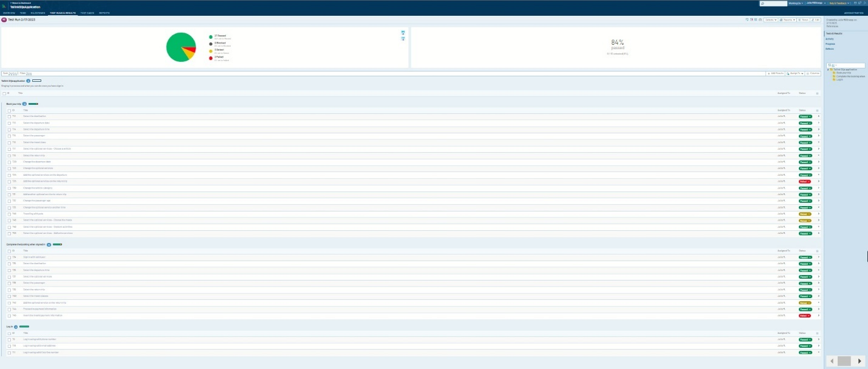

Examples:

Pilt, millel on kujutatud tekst

Kirjeldus on genereeritud automaatseltPilt, millel on kujutatud tekst

Kirjeldus on genereeritud automaatselt

Pilt, millel on kujutatud tekst

Kirjeldus on genereeritud automaatselt

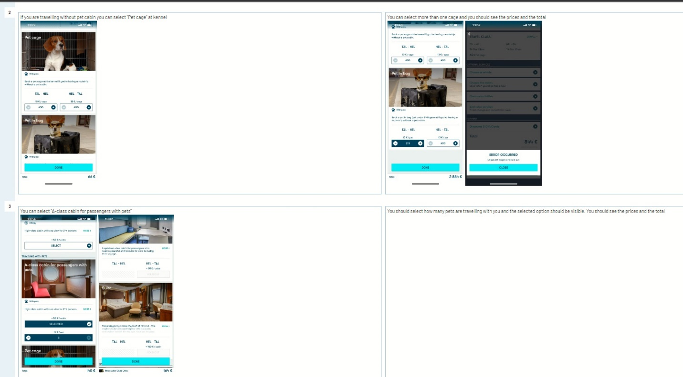

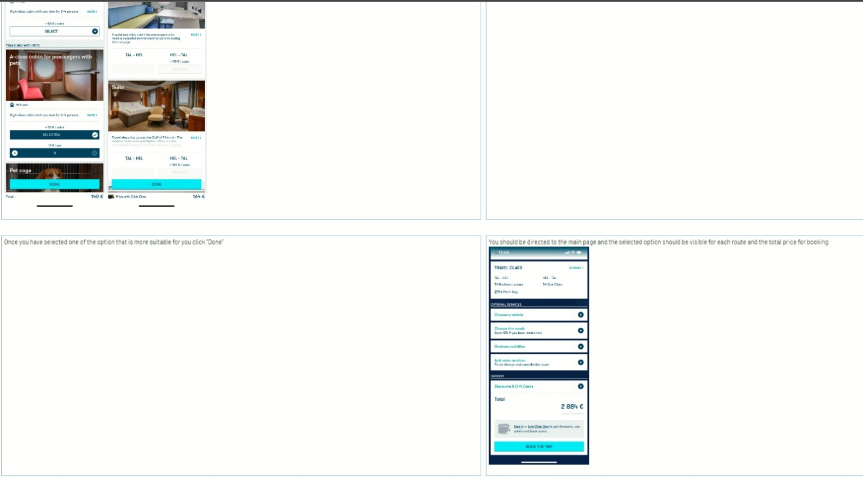

Pilt, millel on kujutatud tekst

Kirjeldus on genereeritud automaatselt

Pilt, millel on kujutatud tekst

Kirjeldus on genereeritud automaatselt

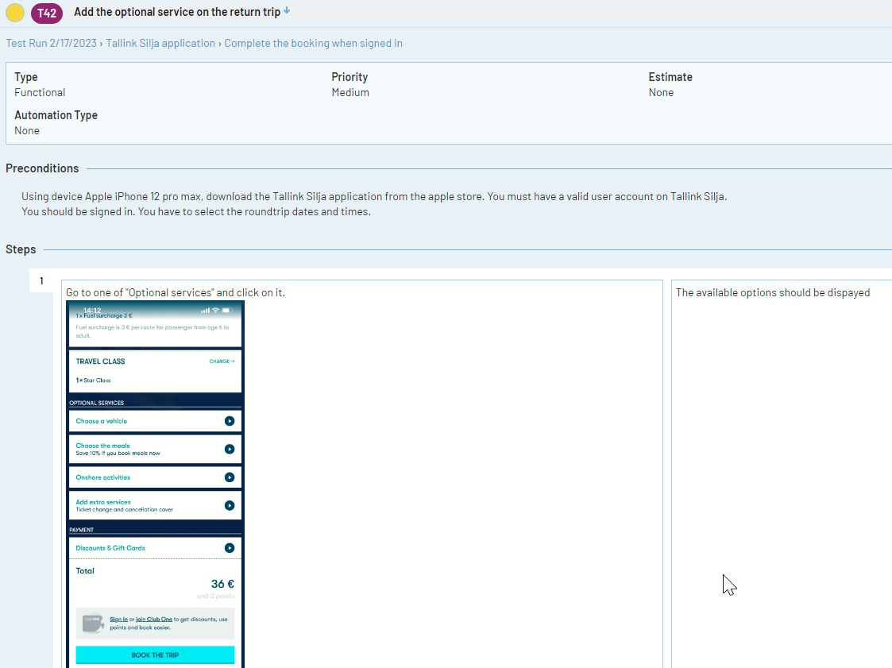Pilt, millel on kujutatud tekst

Kirjeldus on genereeritud automaatselt

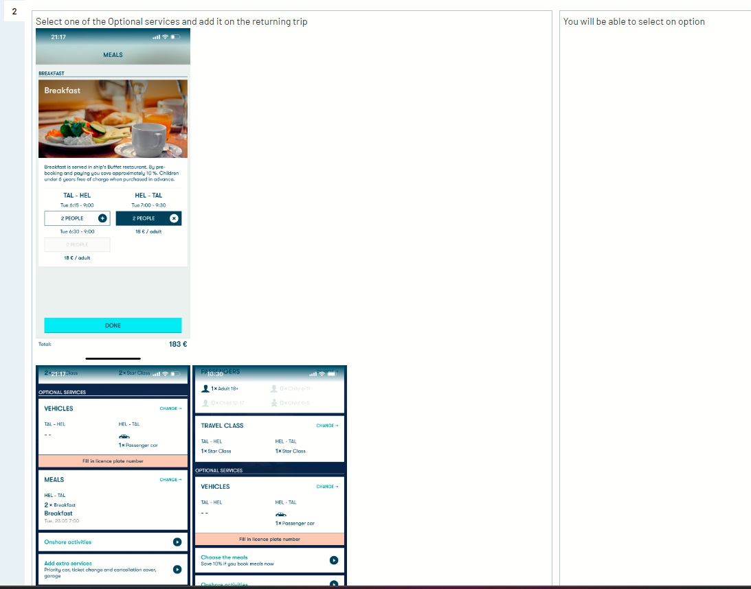

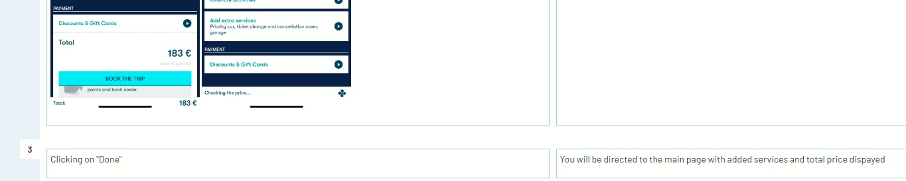

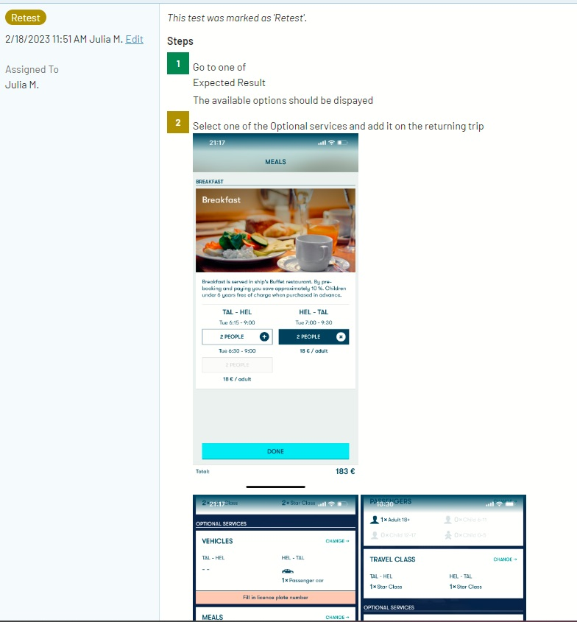

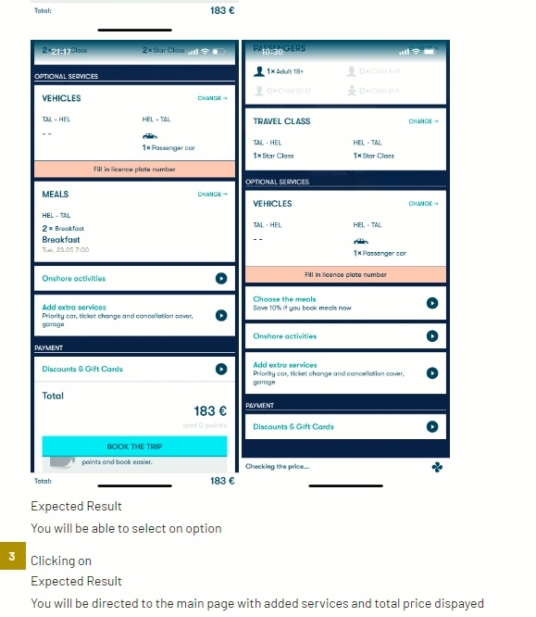

Pilt, millel on kujutatud tekst

Kirjeldus on genereeritud automaatselt

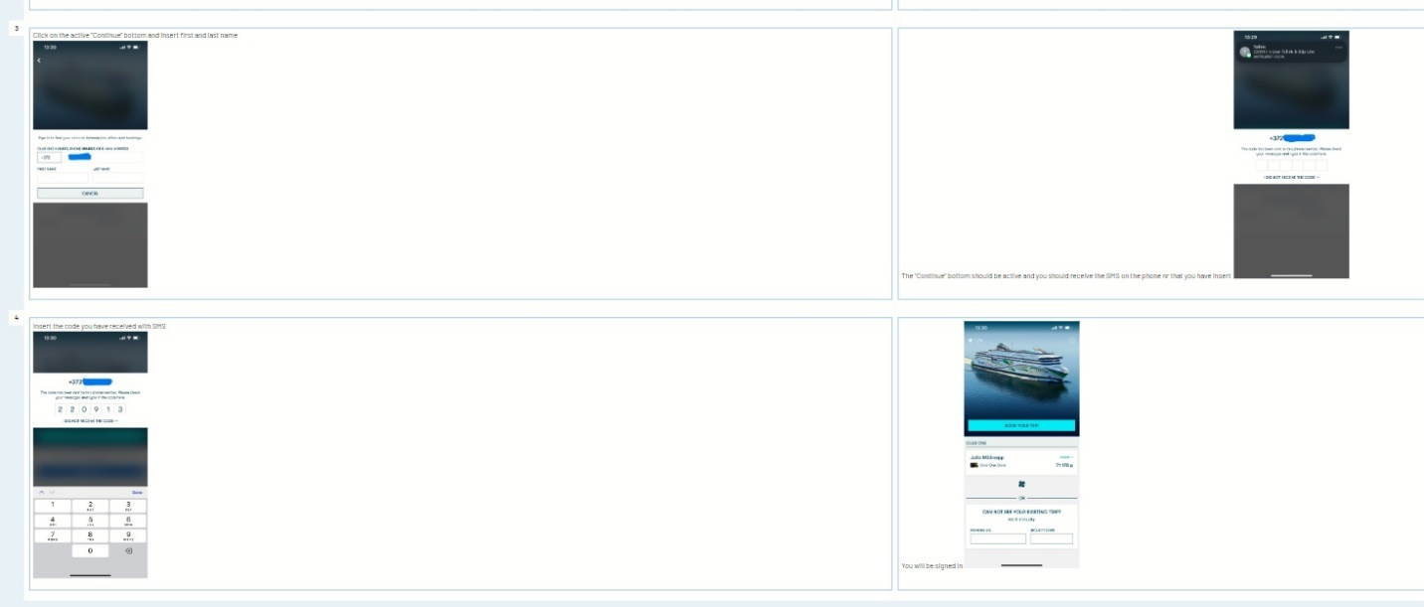

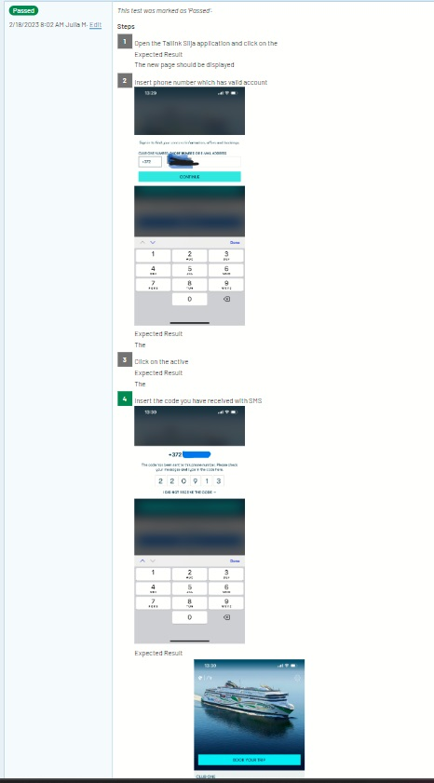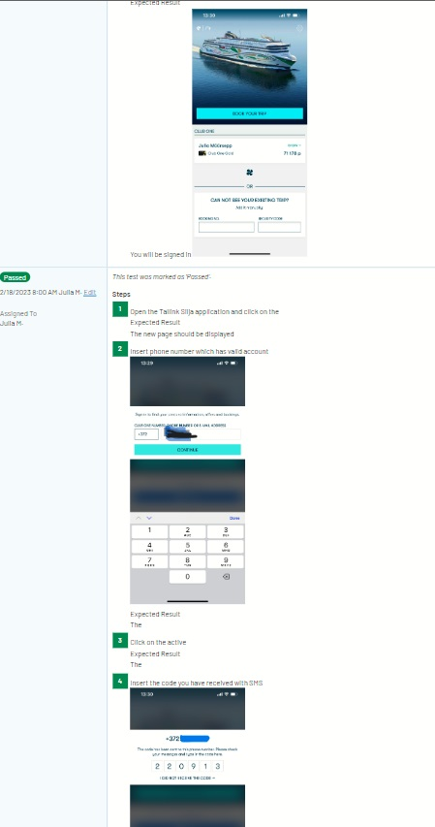

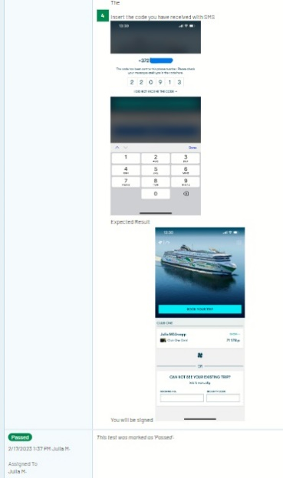

Pilt, millel on kujutatud tekst

Kirjeldus on genereeritud automaatselt

Pilt, millel on kujutatud tekst

Kirjeldus on genereeritud automaatselt

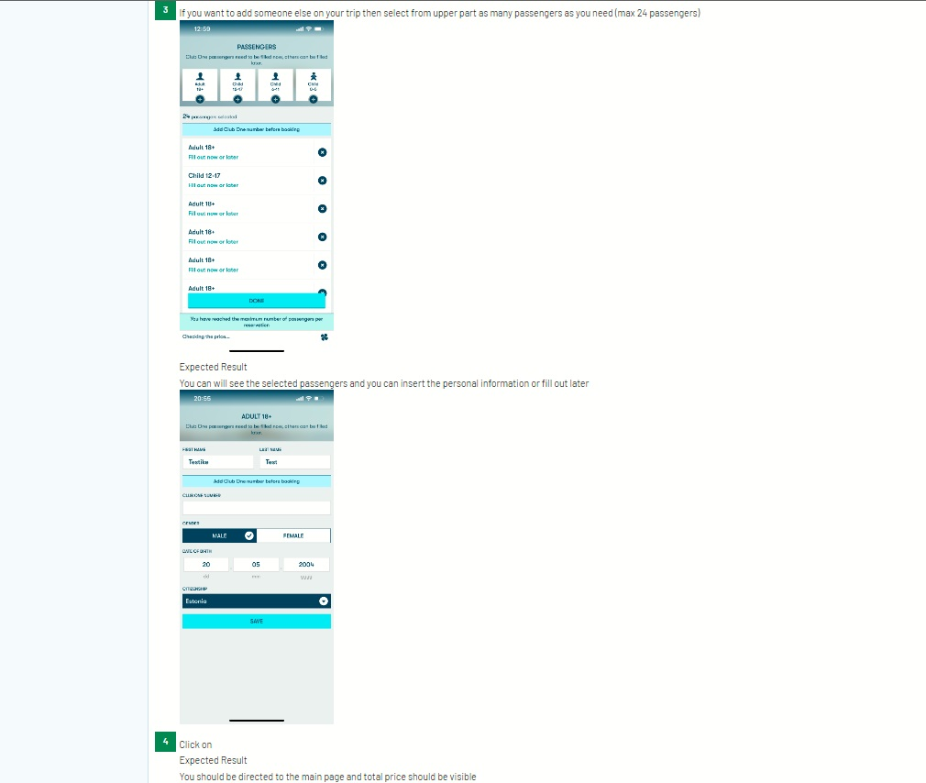

Pilt, millel on kujutatud tekst

Kirjeldus on genereeritud automaatselt

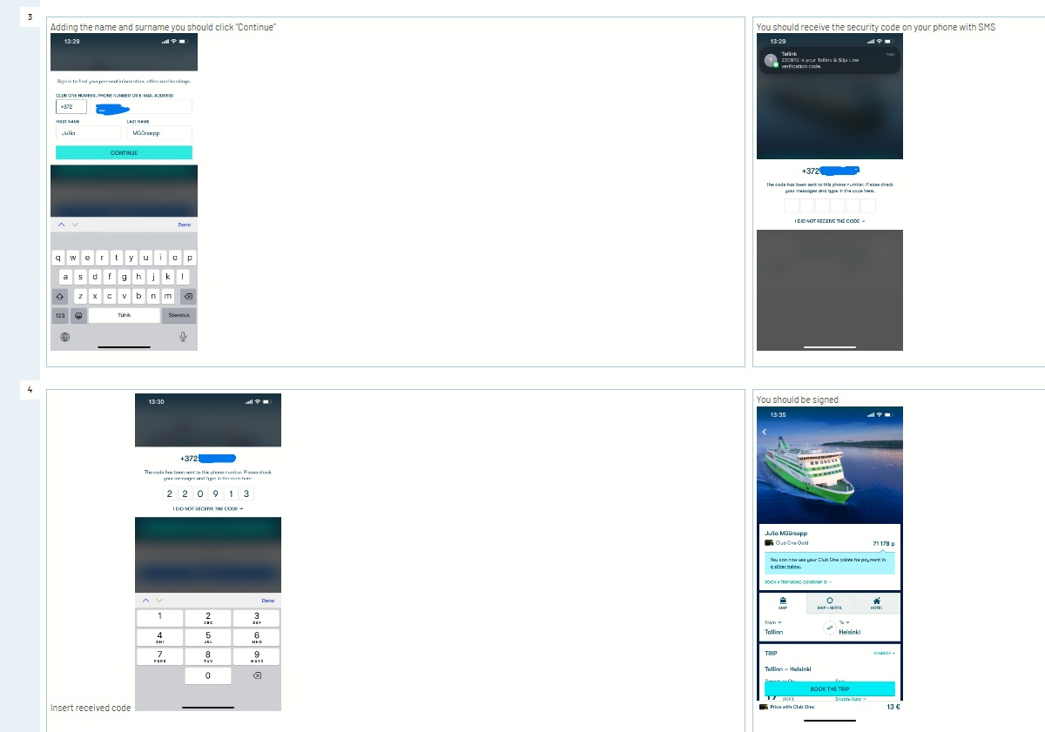

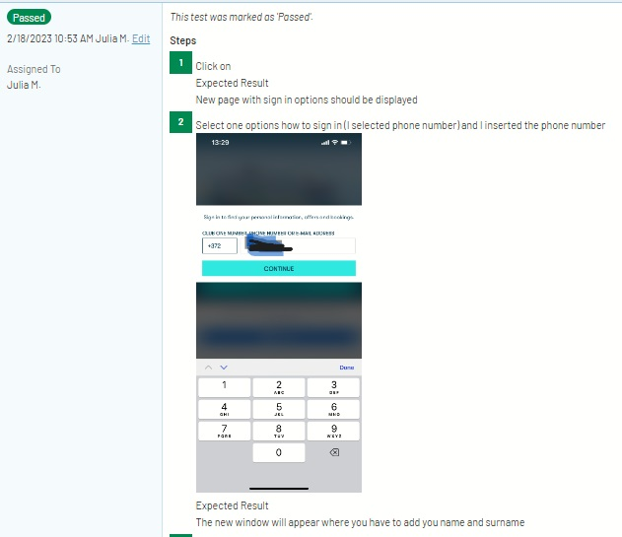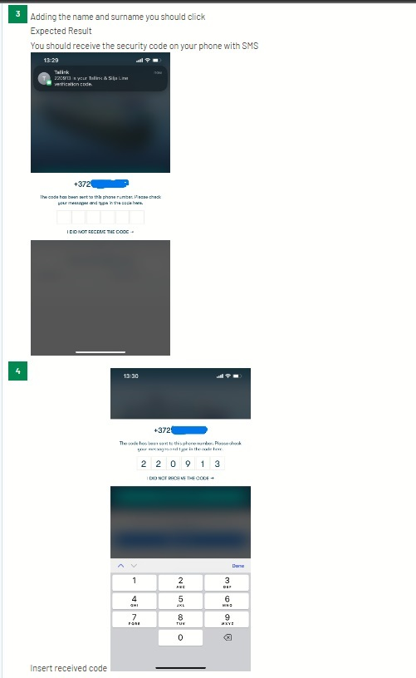

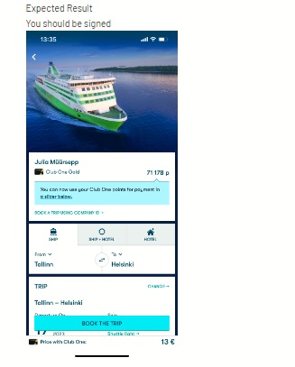

Pilt, millel on kujutatud tekst

Kirjeldus on genereeritud automaatselt

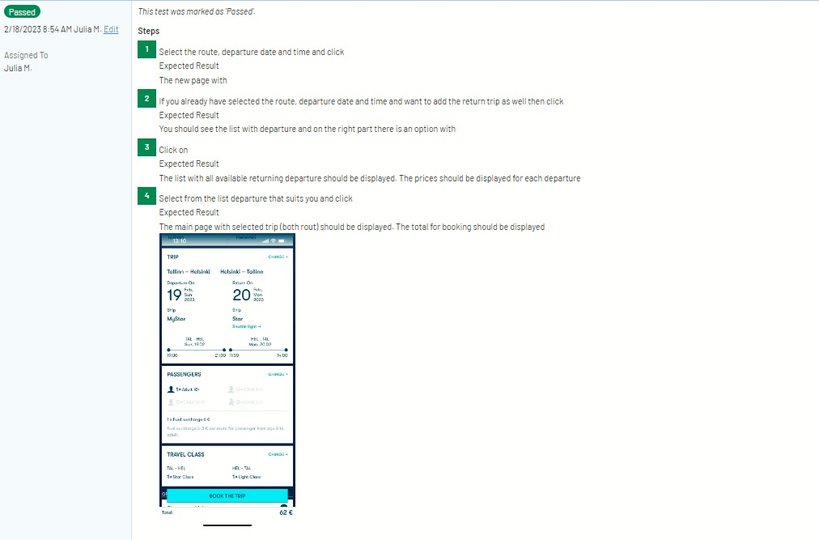

Pilt, millel on kujutatud tekst

Kirjeldus on genereeritud automaatselt

Pilt, millel on kujutatud tekst

Kirjeldus on genereeritud automaatselt

Pilt, millel on kujutatud tekst

Kirjeldus on genereeritud automaatselt

# Funded issues/bugs

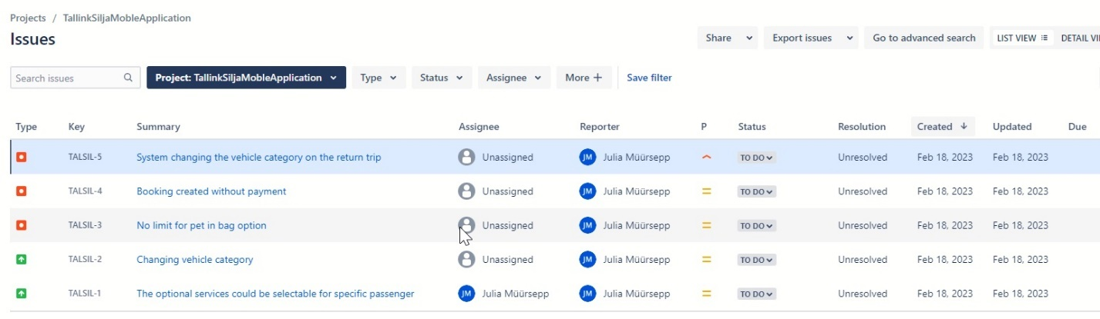

Pilt, millel on kujutatud tekst

Kirjeldus on genereeritud automaatselt





Pilt, millel on kujutatud tekst

Kirjeldus on genereeritud automaatselt

Pilt, millel on kujutatud tekst

Kirjeldus on genereeritud automaatselt

# 

# ImprovementPilt, millel on kujutatud tekst Kirjeldus on genereeritud automaatselt

Pilt, millel on kujutatud tekst

Kirjeldus on genereeritud automaatselt

 Those two examples are very basic, but I think that those should be the first to consider as those two options are the most common that end-users would appreciate.

I think that information for “tricky” or nonstandard options should have some pop-up or added information so the end user experience could be more pleasant, understandable, and user-friendly.

# Test Design techniques

Experience-based – as I have used this application, then I had experience where and what to check.

Exploratory – to check what and how application works, what could be tested and how it should be tested.

Functional – what functions are working and how they work.

Error Guessing – based on experience I knew where and how to check errors hoping that I can recreate them.

State Transition Testing – checking how one function leads to another one to end with expected results.

Security – checks if the login is secure and what functionality is added to ensure that the login is secure.

Automation – used screen recording to recreate and record bugs.

# Reflection

The application has many options and functions. Many of them are connected one to each other.

I selected step by step action, and I think that it was a good strategy for testing this application.

I tried to create unusual or not standard situation to check if the application works as, it should.

I had some issues with some tools that I used, but in the end, I managed to make them all work.

I think I could have needed some more time to be more detailed for the smaller and more specific things.

The application itself has many potentials, but it needs some implementation and some functions to be added. Like in many other applications, some bugs came out and could make some end-users unhappy or even angry, but I think the development team is working to fix and to make this application better.

I know that I need to keep practicing and try to use some new tools and techniques. However, this project was a good starting point.